A small health disadvantage could cause a big employment disadvantage in a competitive labour market

# Introduction

## Para 1: Despite working age health improving in the UK, rates of working age inactivity due to ill health have increased.

Recent research has indicated that people of working age who report limiting longstanding illness (LLTI) are much less likely to be employed and much more likely to be economically inactive than they would have been a generation ago. [ref : Minton, Bartley] This relationship is much stronger for people with unskilled manual labour backgrounds than other occupational groups. Self-assessed health has not worsened in this or other European countries over this time (Kunst et al., 2005), but the employability disadvantage associated with having a LLTI has. This paper describes a computer-based model which has been developed to explore how this could have happened.

## Para 2: Explanations as to why this has occurred have been very politicised.

The computer-based model incorporates just two parameters, one relating to ill health of a candidate, and another to the number of competitors for a position. The model assumes that getting a job is essentially a ‘winner-takes-all’ process, in which the best of a number of candidates for a job get all of the reward (a job), and all other candidates get nothing. Using a computer-based model in this way is useful as a tool for demonstrating the logical implications of making particular assumptions in a complex system incorporating nonlinearities, where these implications may not be immediately apparent. The R code used to perform the simulations is presented on the appendix.

# Methods

## Para 1: We developed a simple mathematical model that indicates how this could have occurred due to labour markets becoming more competitive.

Mathematical models are commonly used in health technology assessments to help NICE and other health based decision making organisations make coherent, evidence-based decisions. The role of this model is more as tool for exploring the logical ecological consequences of accepting a series of individual level assumptions about job selection processes. Because of nonlinearities, small changes at the individual level can lead to large changes at the ecological level [ref Ormerod, Schelling]. These logical implications may not be apparent without adopting a formal model, because it is more intuitive to assume that inputs and outputs are broadly proportional to one another [Ref Nisbett]

## Para 2: The model formalises a number of assumptions and shows what they imply if combined

The assumptions made in the model are: 1) that getting a job is essentially a winter-takes-all process; 2) that health is one of a number of factors that influences how ‘fit’ a candidate is likely to be for a job; 3) that people have ‘good days’ and ‘bad days, variation in performance, but that this variation is around a central level; 4) that people in poorer health have on average a lower level of job fitness than otherwise similar people in good health.

## Para 3: There is the assumption that getting a job is basically a winner-takes-all process

To assume that getting a job is essentially a winter-takes-all process is to say that if one candidate’s performance in the selection process is 95% as good as another candidate’s, then this candidate will not receive 95% of the ‘reward’ for this performance. This is the assumption that means the relationship between inputs and outputs can be nonlinear.

## Para 4: There is the assumption that people have an average level of fitness and there is some variation between these levels.

Some further assumptions are that: each candidate has an ‘average’ level of fitness; there is some level of variation around that average level; and that there are fundamentally just two types of candidate – healthy candidates and health impaired candidates – who apply for jobs. Additionally, there is the assumption that if a person’s employability falls below a certain threshold then they effectively become ‘unemployable’. If, for example, a 62 year old has specialised for the previous 40 years in a particular occupation, and there are currently only 10 new opportunities in that field per year, and the candidates needs on average to apply for 100 positions to be offered one job then it will take that person on average to years to get a job. If the retirement age is 65 then that person is effectively ‘unemployable’ as they could expect employment *after* they are due to retire, and so due to move beyond working age.

## Para 5: The model takes the following form

The way the model is implemented is described briefly as follows: a job selection process is represented by selecting from a series of candidates who each demonstrate a given level of performance of that position. The performance that each candidate demonstrated on that occasion is represented by a random draw from that particular candidate’s ‘performance distribution’. The ‘healthy’ candidates are all represented by the same performance distribution, and the health impaired candidates by this same distribution by shifted down by a given amount, d. The model simulates the proportion of trials where a health impaired candidate ‘wins’ a job over one or more healthy candidates.

## Para 6:

A number of variations of this model are run, for a wide range of permutations of k, the number of healthy candidate the health impaired candidate completes against, and d, the degree of job fitness disadvantage due to ill health that the health impaired candidate has. In order to operationalise the model, the Normal distribution was used to represent variation in candidates’ performance, and the results are likely to be somewhat contingent this choice of distribution. The process is shown graphically in Figure 1 below.

**Employer’s appraisal of candidate’s job fitness**

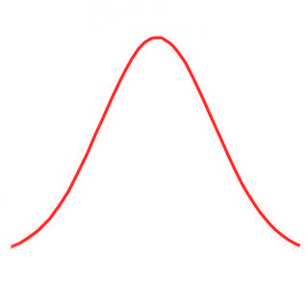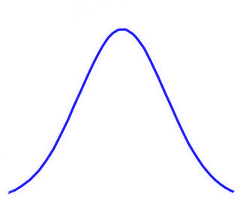

B

A

*d*

***Job 1***

***Job 2***

***Job 3***

***Job 4***

*Worse*

*Better*

Figure Stylised job selection model

## Para 7

Although an analytic solution to the problem is possible when using this distribution, the simulation approach has the advantage of being relatively easy to produce and follow, so of course being readily adaptable to the other distributions and the incorporation of different assumptions and layers of simulation complexity.

# Results

## Para 1: The relationship between p(job) and d is as follows

Where there is a single job rival in full health, the relationship between the degree of health-related disadvantage, d, and the probability of a successful job application is shown in figure X below. The probability of the disadvantaged candidate presenting as the better candidate decreases monotonically with the degree of disadvantage.

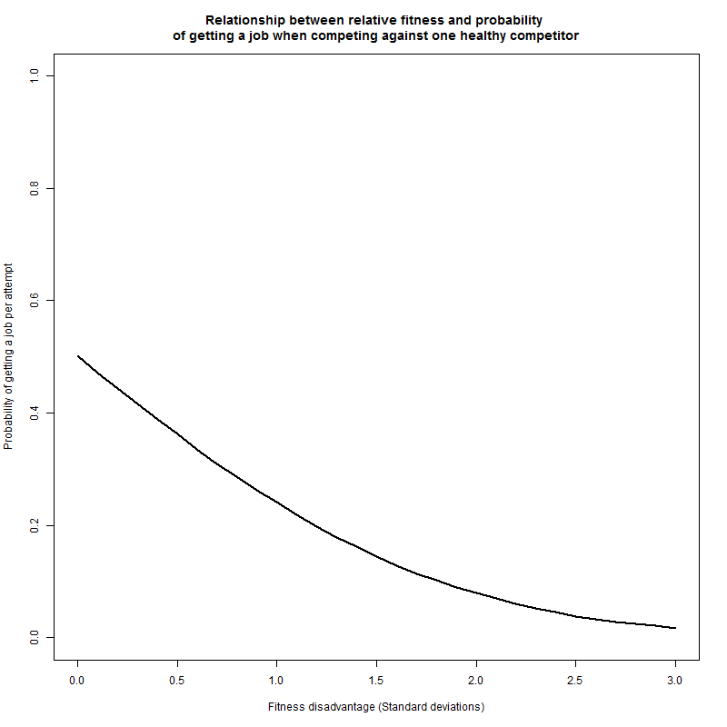

## Para 2: The relationship between p(job) and k is as follows

The relationship between the number of healthy competitors, k, and the probability of the health impaired candidate presenting as the best candidate is illustrated in figure X. In this figure, the degree of disadvantage d has been held constant at 0.5, i.e. half a standard deviation below the mean fitness level of the candidates in full health. As the number of competitors increases, the probability of the health impaired candidate winning the job decreases. Because of the initial disadvantage, however, the probability of getting the job is lower than what would be expected of a nonimpaired candidate irrespective of the number of candidates.

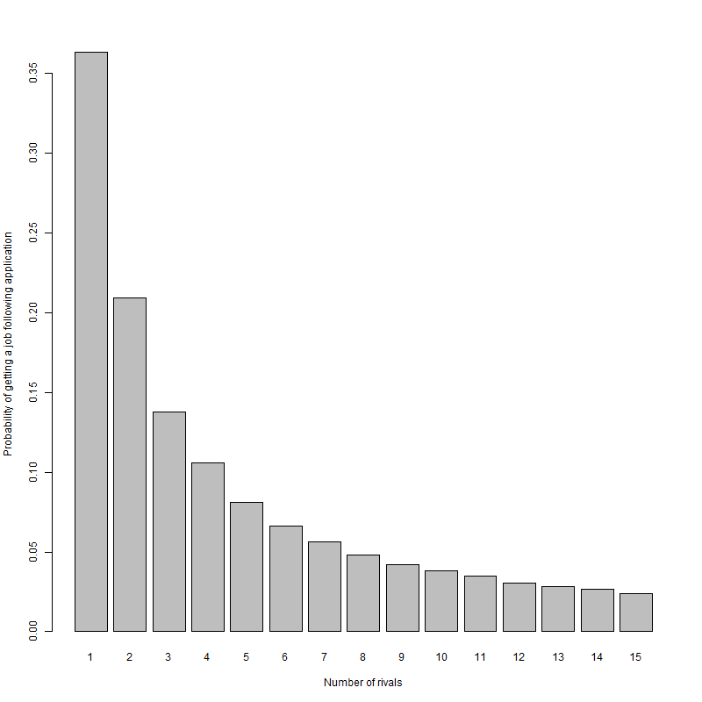

## Para 3: The relationship between p(job) and (d, k) jointly is as follows

The way that the number of competitors k and degree of disadvantage d jointly affects the probability of getting a job is shown in figure X below. Figure Y presents the same relationship using the equivalent measure, expected number of applications necessary to get a job. It is seen that someone with a given level of health disadvantage will face an increasing challenge to their chances getting a job as the number of competitors per place increases. It is further noted that this relationship is nonlinear, such that both d and k have to be specified in order to identify what the effect on employability is. As has been stated previously, the precise values predicted have not been calibrated empirically, and just exist to show how this nonlinear relationship could emerge as a result of modelling a series of relatively innocuous assumptions about social and economic factors which could mediate health factors.

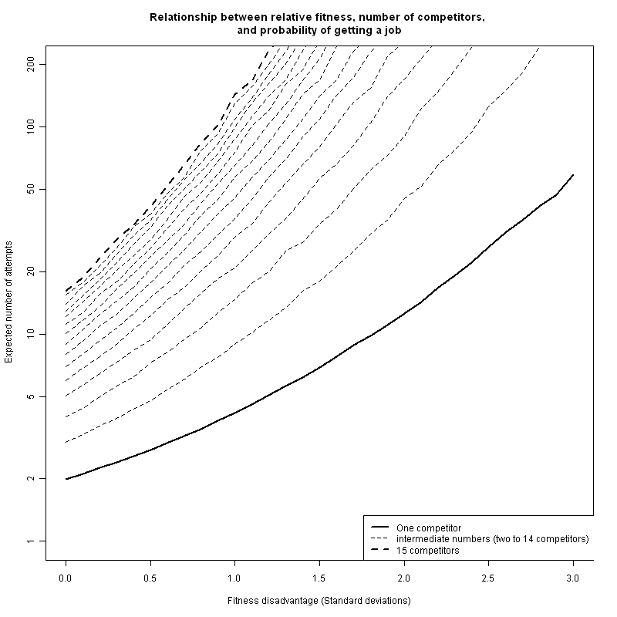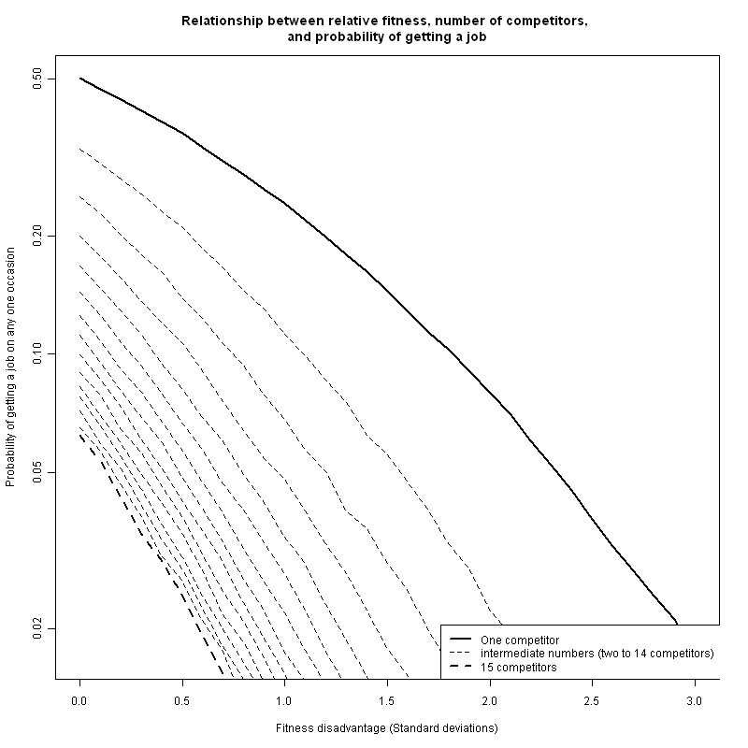

## Para 6: How an increasing proportion of the working age population could become unemployable due to ill health even without worsening of population health

If we consider that someone who requires on the average 200 applications to receive one job offer is effectively ‘unemployable’, then we can observe how increased competition for jobs (increased k) will push an increasing proportion of the working age population into the ‘unemployable’ category. The threshold in this example is equivalent to the probability of employment of 0.005.

With just one competitor per job, people remain ‘employable’ even where these health related disadvantage is 2.3. With two competitors in full health, a d of 1.6 starts to render someone ‘unemployable’. With three candidates without impairment per job, someone with a d of 1.3 becomes ‘unemployable’. This relationship continues with each addition competitor. In the example presented, with 15 unimpaired competitors per place, a person becomes ‘unemployable’ when their d level is only 0.2. Note that d refers only to the degree of disadvantage relative to the average ,and does not imply the proportion of the population with that level of d. A further nonlinear relationship between k, d, and the proportion of the population affected may be assumed, in that if the ‘unemployability’ threshold reaches a d level that is relatively common in the working age population, then a large rise in economic inactivity may emerge.

Four rivals, disadvantage of 1 sd

Eight rivals, disadvantage of 0.5 sd

11 rivals, disadvantage of 0.3 sd

Five rivals, disadvantage of 0.8 sds

154 4 1.0 0.04804

83 8 0.5 0.04829

56 11 0.3 0.04937

125 5 0.8 0.04945

# Discussion

## Summary of what found

This model indicated that it may be plausible to assume that a level of health impairment that would not have been severe enough to exclude people from the labour market in the 1970s could nevertheless exclude people from the labour market in the 1990s and beyond. This is because of the proposed relationship between health impairment and labour market competitiveness, represented in this model by the number of competitors for a position.

## Shortcomings

The purpose of this model is primarily as a way of testing and demonstrating the logical implications at the ecological level of combining a number of relatively uncontroversial individual level assumptions. The potential shortcomings of the model are that these individual level assumptions are inadequate, either due to being incorrect or excessively simplistic. Another potential shortcoming of the model is that a Normal distributions were used to represent both impaired and nonimpaired jobseeker populations, and the dependency of the results presented on these assumptions have not been full assessed. The model here is intended primarily as a pedagogic tool for encouraging clearer thinking about this important economic and health issue. In using a model in this way it is important that the right balance is struck in terms of model sophistication and model accessibility. If the appropriate balance has not been struck then this is a shortcoming of the model.

## How relates to other findings

This stylised model owes a conceptual debt to work by Beatty, Fothergill and McMillan [refs] in relationship to ‘hidden unemployment’, and so its relationship to this research is not coincidental. This research suggested that, during the early 1990s, there may have been a large number of people in employment whose degree of health impairment was severe enough that they would have met the eligibility criteria for incapacity benefit or invalidity benefit. However, this latent ill health among the working age population only became realised as increased claims invalidity or incapacity benefit claims when the recession of the early 1990s occurred, as less healthy members of the workforce may have been both most likely to be made redundant and least likely to find new employment. Faced with a choice between remaining on unemployment benefits with only limited expectation of finding a new job, or of making a legitimate claim for IVB/IB, which paid more and did not have the same jobseeking conditionality, many of the less healthy people laid off during this recession may have made the economically rational choice, and in doing so permanently exited the labour market.

Recent research by this author has indicated a complex relationship between gender, occupational class, and limiting long term illness as predictors of whether people are in work, seeking work or economically inactive. In particular, this research showed that the presence of a limiting long-term illness was much more strongly associated with being economically inactive for people of unskilled and semi-skilled manual labour backgrounds than nonmanual backgrounds; additionally, it showed this relationship to have grown much stronger since the 1970s. In terms of the variables included in this stylised model, there are two possible, and not mutually exclusive, explanations for these observations. Firstly, it may be that a ‘limiting long-term illness’, as responders were asked to interpret it, was more likely to be a physical than a mental disorder, and as a result was likely to be the sort of health deficit which led to a larger job-specific health deficit for manual than non-manual work. Secondly, the long transition towards an increasingly post-industrial economic is likely to mean that there is a greater scarcity of manual than nonmanual work, and so k is greater for these occupational groups than non-manual workers.

Beatty & Fothergill

Mine

Two/three others.

## Implications for research

This paper has illustrated the potential benefits to epidemiological research and theorising about epidemiological processes of using a computer based microsimulations as tools for teaching out the implications of making and combining a series of assumptions about an epidemiological phenomenon. The use here of a microsimulation model as a thinking tool for pedagogic aid contrasts with uses more common in the health sciences such as a decision tool by NICE for making resource allocations models and synthesising multiple sources of evidence. There are two avenues here for the development of what is presented here into further research. Firstly, the model developed here could be made more sophisticated, incorporating and being parameterised by various forms of evidence from the literature. Calibration could be performed by comparing the predictions of the model to reality over periods where the data are already known. Secondly, the spirit of the approach described here could be followed to encourage health researchers to adopt the stylized and pedagogic modelling approach for exploring other complex health science areas.

Adding complexity and empirical calibration

Survey research on number of jobs applied for per success

Survey into possible class disparities in health of women of working age who don’t work

Application of approach to other forms of disadvantage 9e.g. employment, qualifications

## Implications for practice

Recognition that once someone of poor health becomes unemployed it may be very difficult for them to get a job again.

Consideration of sheltered employment schemes to keep people in labour market

Recognition that efficient and accessible labour markets may be mutually incompatible.

The replacement of IB with Employment and Support Allowance (ESA), and with it the replacement of ‘sick notes’ with ‘fit notes’,(BBC, 2010) and the Personal Capability Assessment (PCA) with the Work Capability Assessment (WCA) as the means to assess eligibility has been controversial, with questions raised about the new test’s ability to sufficiently recognise the adverse effects of mental health conditions and fluctuating conditions.(Anonymous, 2010; Dryburgh and Lancashire, 2010; Gentleman, 2011) WCA also appears to have a generally higher threshold than PCA, with reassessments of existing IB claimants categorising around 30% of claimants as only eligible for JSA, and 40% as capable of some work and so eligible for the lower-paying employment support (ES) component of ESA.(Groves, 2011) The accuracy of the test is also in doubt, with around 40% of appealed decisions overturned.(Margrath, 2010)

# Appendix: R code

# K : number of rivals

# d : disadvantage (in standard deviations)

# n : number of simulations

n <- 100000

K <- 1:15

D <- seq(0,3, by=0.1)

Output <- expand.grid(k=K, d=D, prob=NA)

for(d in D){ # for each of a range of levels of disadvantage

for (k in K){ # for between 1 and 15 rivals

A.win <- vector("numeric", n)

for (i in 1:n){

B <- rnorm(k) # k draws from a normal distribution with mean of 0 and sd of 1

A <- rnorm(1, -d) # one draw from a normal distribution with a mean of -d and sd of 1

A.win[i] <- as.numeric(A > max(B)) # produces a vector with 1 if A is the greatest number; 0 otherwise

}

prob.A.win <- sum(A.win) / n # calculates the proportion of times where A is the greatest value

Output[Output$k==k & Output$d==d, "prob"] <- prob.A.win

}

}

####